**DOKUZ EYLÜL UNIVERSITY**

**ENGINEERING FACULTY**

**DEPARTMENT OF COMPUTER ENGINEERING**

**ANDROID APPLICATION THAT TRACKS THE STATUS OF BIPOLAR PATIENTS**

**by**

**Mehmet UYĞUT**

**Ömer Selim ATİLA**

**Bahar YILMAZ**

**Advisor**

**Dr. Meltem YILDIRIM**

**February, 2021**

**İZMİR**

**ANDROID APPLICATION THAT TRACKS THE STATUS OF BIPOLAR PATIENTS**

**A Thesis Submitted to the**

**Dokuz Eylül University, Department of Computer Engineering**

**In Partial Fulfillment of the Requirements for the Degree of B.Sc.**

**by**

**Mehmet UYĞUT**

**Ömer Selim ATİLA**

**Bahar YILMAZ**

**Advisor**

**Dr. Meltem YILDIRIM**

**February, 2021**

**İZMİR**

**SENIOR PROJECT EXAMINATION RESULT FORM**

We have read the thesis entitled **“ANDROID APPLICATION THAT TRACKS THE STATUS OF BIPOLAR PATIENTS”** completed by **Mehmet UYĞUT, Ömer Selim ATİLA** and **Bahar YILMAZ** under advisor of **Dr. Meltem YILDIRIM** and we certify that in our opinion it is fully adequate, in scope and in quality, as a thesis for the degree of B.Sc.



Dr. Meltem YILDIRIM



Advisor



Committee Member Committee Member



Prof. Dr. Alp KUT

Chair

Department of Computer Engineering

**ACKNOWLEDGEMENTS**

Thanks…

First of all, we are very grateful because we completed to the project within the given time by the our advisor Dr. Meltem YILDIRIM. We would like to thank Meltem YILDIRIM for his suggestions and advice, as well as for giving us the chance to do this project.

Bahar YILMAZ

Mehmet UYĞUT

Ömer Selim ATİLA

**ANDROID APPLICATION THAT TRACKS THE STATUS OF BIPOLAR PATIENTS**

**ABSTRACT**

Bipolar disorder is a very important health problem today. Bipolar disorder is a condition that affects the daily lives of patients too much. Bipolar disorder is a psychological disorder that causes impairment in a person's mood, energy, and ability to complete social activities. Unlike the ups and downs that occur in the flow of daily life, people with bipolar disorder may experience problems in the work environment, school life and in their relations due to sharp ups and downs. Studies show that about 5% of people struggle with bipolar disease. In today's society, people are more and more likely to have bipolar disorder. The relationship between doctor and patient is very important in bipolar disease. The better the doctor knows about the condition of his patients, the better and quicker the treatment process takes place. At the same time, drug use is a very important factor in bipolar disease. Regular intake of medications significantly affects the patient's development. This thesis is about to developing an android application for improving the doctor and patients relationship, observation the patients for themselves, information the doctors know about their patients and medicine use by patients.

The developed application has many different features. Features that the patient has to do by himself / herself are; alarm system for the use of drugs and a questionnaire that measures the patient's daily feelings and thoughts. At the same time, the majority of the application is on the phone sensors. The application records the daily step count, call logs and social media usage in the background using the phone's sensors. The information collected by these sensors contains great clues about changes in bipolar patients' lives. All the data collected is stored in a database with the parts filled in by the patient. Thus, doctors can closely follow the changes in their patients' lives and can intervene in their patients when they see a significant difference.

**BİPOLAR HASTALARIN DURUMUNU TAKİP EDEN ANDROID UYGULAMASI**

**ÖZET**

Bipolar bozukluğu günümüzde çok önemli bir sağlık sorunudur. Bipolar bozukluğu hastaların günlük yaşamlarını çok fazla etkileyen bir rahatsızlıktır. Bipolar bozukluğu kişinin duygudurumunda, enerjisinde ve sosyal aktiviteleri tamamlama yetisinde bozulmalara neden olan psikolojik hastalıktır. Günlük hayatın akışında gerçekleşen iniş-çıkışlardan farklı olarak, bipolar bozukluk bulunan kişiler, keskin iniş-çıkışlara bağlı iş ortamında, okul hayatında, aile ve arkadaş ilişkilerinde sorunlar yaşayabiliyor. Araştırmalar gösteriyor ki insanların yaklaşık %5’i bipolar hastalığıyla mücadele halindedir. Günümüz toplumunda insanlar git gide daha fazla bipolar bozukluğa sahip olma yatkınlığındadır. Bipolar hastalığında doktor ve hastanın ilişkisi çok önemlidir. Doktor, hastalarının durumuna ne kadar hakim olursa tedavi süreci o kadar iyi ve hızlı bir şekilde gerçekleşir. Aynı zamanda ilaç kullanımı bipolar hastalığında çok önemli bir etkendir. İlaçların düzenli alınması hastadaki gelişimi önemli bir ölçüde etkiler. Bu tez, doktor ve hastanın iletişimi, hastanın kendisi hakkındaki gelişmeleri gözlemleyebilmesi, doktorun hastanın hayatına dair bilgiler edinebilmesi ve hastaların ilaç kullanımını kolaylaştırmak için bir akıllı telefon uygulaması geliştirilmesi üzerinedir.

Geliştirilen uygulama bir çok farklı özelliğe sahiptir. Hastanın uygulamaya girerek kendisinin yapması gereken özellikler; ilaçların kullanımı için bir alarm sistemi ve hastanın günlük duygu ve düşüncelerini ölçen bir ankettir. Aynı zamanda uygulamanın büyük bir kısmını kaplayan kısmı telefon sensörleri üzerinedir. Uygulamada telefonun sensörlerini kullanarak günlük adım sayısını, arama kayıtlarını ve sosyal medya kullanımını arkaplanda kaydeder. Bu sensörler sayesinde toplanan bilgiler bipolar hastaların hayatlarındaki değişimlerle alakalı büyük ipuçları içerir. Toplanan tüm veriler, hastanın doldurduğu kısımlar ile birlikte bir veritabanında saklanır. Böylece doktorlar hastalarının hayatlarındaki değişimleri yakından takip edebilir ve önemli bir farklılık gördüklerinde hastalarına müdahale edebilirler.

**CONTENTS**

**Page**

PROJECT EXAMINATION RESULT FORM ii

ACKNOWLEDGEMENTS ..iii

ABSTRACT iv

ÖZET v

**CHAPTER ONE**

**INTRODUCTION……………………………………………………..……….……….8**

[1.1 Background Information](https://docs.google.com/document/d/1Y_W1fwTaj0U_sriCLzb-xGNT-bKZ7jk3FHLx72FjUhk/edit#heading=h.1fob9te) 9

[1.2 Problem Definition](https://docs.google.com/document/d/1Y_W1fwTaj0U_sriCLzb-xGNT-bKZ7jk3FHLx72FjUhk/edit#heading=h.3znysh7) 10

[1.3 Motivation/Related Works](https://docs.google.com/document/d/1Y_W1fwTaj0U_sriCLzb-xGNT-bKZ7jk3FHLx72FjUhk/edit#heading=h.2et92p0) 11

[*1.3.1 Monarca System*](https://docs.google.com/document/d/1Y_W1fwTaj0U_sriCLzb-xGNT-bKZ7jk3FHLx72FjUhk/edit#heading=h.tyjcwt) 11

1.4 Goal/Contribution 12

[1.5 Project Scope](https://docs.google.com/document/d/1Y_W1fwTaj0U_sriCLzb-xGNT-bKZ7jk3FHLx72FjUhk/edit#heading=h.2s8eyo1) 12

[1.6 Methodology/Tools/Libraries](https://docs.google.com/document/d/1Y_W1fwTaj0U_sriCLzb-xGNT-bKZ7jk3FHLx72FjUhk/edit#heading=h.17dp8vu) 13

[*1.6.1* *Methodology*](https://docs.google.com/document/d/1Y_W1fwTaj0U_sriCLzb-xGNT-bKZ7jk3FHLx72FjUhk/edit#heading=h.3rdcrjn) 13

[1.6.2 *Tools*](https://docs.google.com/document/d/1Y_W1fwTaj0U_sriCLzb-xGNT-bKZ7jk3FHLx72FjUhk/edit#heading=h.26in1rg) 13

[*1.6.3* *Libraries*](https://docs.google.com/document/d/1Y_W1fwTaj0U_sriCLzb-xGNT-bKZ7jk3FHLx72FjUhk/edit#heading=h.lnxbz9) 14

**CHAPTER TWO**

**LITERATURE REVIEW……………………………………………………………...14**

**CHAPTER THREE**

**REQUIREMENTS / REQUIREMENT ENGINEERING………………….………..17**

[3.1 Functional Requirements](https://docs.google.com/document/d/1Y_W1fwTaj0U_sriCLzb-xGNT-bKZ7jk3FHLx72FjUhk/edit#heading=h.35nkun2) 17

[3.1.1](https://docs.google.com/document/d/1Y_W1fwTaj0U_sriCLzb-xGNT-bKZ7jk3FHLx72FjUhk/edit#heading=h.1ksv4uv) *Functional Requirement for Passive Data*17

[3.1.2 *Functional Requirements for User Inputs*](https://docs.google.com/document/d/1Y_W1fwTaj0U_sriCLzb-xGNT-bKZ7jk3FHLx72FjUhk/edit#heading=h.44sinio) 17

3.1.3 *Functional Requirements for User Display Screen* 18

3.2 Non - Functional Requirements 18

*3.2.1 Performance Requirements 18*

*3.2.2 Hardware Requirements for Development 19*

*3.2.3 Software Requirements for Development 19*

3.3 Usability 19

3.4 Reliability 19

3.5 Portability 19

**CHAPTER FOUR**

**DESIGN…………………………………………………………………...…………...20**

[4.1 Architectural View](https://docs.google.com/document/d/1Y_W1fwTaj0U_sriCLzb-xGNT-bKZ7jk3FHLx72FjUhk/edit#heading=h.3j2qqm3) 20

4.2 Database Design / ER Diagram 21

[4.3 UML Class Diagram](https://docs.google.com/document/d/1Y_W1fwTaj0U_sriCLzb-xGNT-bKZ7jk3FHLx72FjUhk/edit#heading=h.4i7ojhp) 22

4.4 UI Design 23

[4.5 Use Cases 2](https://docs.google.com/document/d/1Y_W1fwTaj0U_sriCLzb-xGNT-bKZ7jk3FHLx72FjUhk/edit#heading=h.2bn6wsx)8

[4.6 Sequence Diagram 2](https://docs.google.com/document/d/1Y_W1fwTaj0U_sriCLzb-xGNT-bKZ7jk3FHLx72FjUhk/edit#heading=h.qsh70q)9

[4.7 Activity Diagram](https://docs.google.com/document/d/1Y_W1fwTaj0U_sriCLzb-xGNT-bKZ7jk3FHLx72FjUhk/edit#heading=h.3as4poj) 30

**CHAPTER FIVE**

**IMPLEMENTATION….………………………………………………...…………...32**

5.1 Main Screen and Login 32

5.2 Self-Assessment 38

5.3 Alarms 40

5.4 Statistic 42

**CHAPTER SIX**

**TEST AND RESULT.….………………………………………………...…………...46**

**CHAPTER SEVEN**

**CONCLUSION, CONTRIBUTIONS, FUTURE WORK………………..……..…..47**

**REFERENCES……………………………………………...………………..…….…48**

**CHAPTER ONE**

**INTRODUCTION**

**1.1 Background Information**

Along with the developing health conditions in the world, many new diseases were diagnosed. Studies have been carried out especially in the psychiatry field and this health science has started to come to the agenda. After those days, it became important to monitor the patients' findings and make a diagnosis, but in some diseases, this was not possible. It is understood that Bipolar Disease, which is one of those diseases, is a difficult disease to diagnose due to the changing mood of patients. Because the patients were not sensitive, sensitive and inclined to give up treatment in this period.

According to the NIH’s (National institute of Mental Health) website, nearly %5 of adults experience bipolar disorder at some time in their lives. This numbers is a huge and need an attention to reduce and control this number.

It is becoming increasingly difficult to measure some of the symptoms of Bipolar Disease. With the developing and changing technology, it has been determined that there are many symptoms that affect the lives of these patients and that they are in a manic or depressive period. (International Journal of Methods in Psychiatric Research Int. J. Methods Psychiatry. Res. 25 (4): 309–323 (2016) Published online 1 April 2016 in Wiley Online Library). There are some tests for comparing them and deciding when. (Hamilton Depression Rating scale and Young Mania Rating Scale).For the usage of this tests, collecting patients’ information is extremely important. In bipolar disorder, steady and accurate collection of information collected from patients is very important for patients to continue their lives.

It has become essential to benefit from technology because it is not possible to follow a patient’s mental health all the time. Therefore, the use of phones that are constantly with patients and can transmit information to us can improve the quality of life of patients.

**1.2 Problem Definition**

According to the researches, if the information to be used in the diagnosis of Bipolar disease is obtained only by interacting with the patient, it becomes less reliable information. The preliminary intuition of patients to see their own symptom pares and to monitor themselves disappears. Long-term monitoring and constant follow-up of the disease are lost. In addition, patients are more likely to give up treatment. (Collecting Survey and Smartphone Sensor Data with an App: Opportunities and Challenges Around Privacy and Informed Consent).

With the developing technology, we obtained a lot of data and many of these data became easier to use. The type and usage of the data collected and analyzed since the past has changed. According to the studies (like Monarca System), there are some data that can be used in the diagnosis of the disease. Some of these data;

• Incoming text message,

• Outgoing text messages,

• Duration screen on (second/day)

• Number of time screen on

• Number of characters in incoming text message

• Number of characters in outgoing text message

• Incoming calls

• Outgoing calls

• Missed calls

• Sleep length

• Activity level

Researches show that, nowadays it is very difficult to meet a person who does not use a phone. Naturally, this also applies to patients with bipolar disorder. At the same time, the development of smartphones today has made them more than just a phone. Due to the sensors of the smartphones and the extreme prevalence use of smartphones, a lot of information about people has become available on phones for researches or helping them. Therefore, collecting the information exemplified above from phones can greatly contribute to bipolar disorder patients.

Also, medication use is common and important in bipolar disorder. In addition, medication use of patients should be regulated to solve this problem. This becomes resolvable with an alarm system to be installed on patients' phones.

**1.3 Motivation/Related Works**

***1.3.1 Monarca System***

The main purpose of monarca is to create an application that helps bipolar patients. In this application, some information is collected and sent to doctors, and it is analyzed by doctors to help patients. Positive effects were observed in patients as a result of the monarca system. This situation has been a guide that the application made in the project can also give a successful result. As a result of the different information we collect and the improvements we make, our application can have a positive effect on patients' lives.

**1.4 Goal/Contribution**

The main purpose of this project is to create a system where patients away from this insight can provide information without coming to the clink, and at the same time, doctors who receive this real-time information can track them, analyze them more easily and follow these patients.

In order to realize this situation, an android application will be made in this project. This project will store the daily or weekly information collected from the phone via a database and this information will always be accessible by authorized persons (doctors). In this way, doctors will be able to easily make inferences about patient’s condition even when they are not interviewing them. At the same time, medicine use is very important for patients with bipolar disorder. Regarding this situation, an alarm system will be added to the application and patients will be provided with regular medication. Thanks to the developed application, both doctors will be able to track their patients’ situation more closely and patients will be able to fulfill their responsibilities more easily.

**1.5 Project Scope**

Bipolar disorder (BD) is a chronic mental illness characterized by alternating phases of depression and phases so-called manic or hypomanic. During depressive states, patients experience symptoms ranging from sadness, hopelessness (including suicidal ideation), loss of energy, anhedonia, and psychomotor retardation. While patients change between these states, they cannot be aware of their status and this situation slow down theirs treatment process.

The project scope will be helping bipolar patients without disturb them. For this purpose, project will use their smartphones’ sensors like duration screen, activity level etc. and some questionnaires. Patients’ status will be monitoring by their doctors. So that doctors can form an opinion about their patients easily. Also application will help patients about their medicine usage with alarm application.

**1.6 Methodology/Tools/Libraries**

***1.6.1 Methodology***

The methodologies will be used in the project is an android application for android phones. In the application sensors collect a lot of data like incoming and outgoing calls, counting patient’s daily steps and social media usage. In addition to these, there will be a questionnaire that is expected to be made from the patient on a daily or weekly basis. All these collected information will be stored in a database and presented to doctors. Finally, it will be ensured that patients use their medicines regularly and correctly by making an alarm part in the application in order to facilitate the use of their medicines and help them in their daily life.

***1.6.2 Tools***

The tools will be used in the project are Android Studio with kotlin language and server tool called firebase. Android studio and kotlin are sites prepared to develop applications in android Smartphones. The reason to prefer firebase application as database in the application is that firebase can work very compatible with android studio. Since the tools we use make it very easy to develop applications for phones, they are very suitable for developing an application that users can use without difficulty.

***1.6.3 Libraries***

In the project, besides the general libraries of the android studio, many libraries will be used to communicate the sensors with the application. For example, incoming and outgoing calls will be stored thanks to the callLogs library and SensorEventListener library for pedometer (counter for steps).

**CHAPTER TWO**

**LİTERATURE REVIEW**

***2.1 Monarca System***

Following the MONARCA studies adjustments to the self-monitoring part of the system were made and a new integrated feedback loop, based on prediction models including both subjective measures and automatically generated behavioral data on measures of illness activity, was established. [1]

A study nurse with experience with bipolar disorder is assigned to the patients allocated to the intervention group of the MONARCA II trial. The MONARCA II study nurse is responsible for the integrated feedback loop. Patients allocated to the intervention group of the MONARCA II trial have the Monsenso application in- stalled on a smartphone, and this automatically transfers the self-monitored subjective measures and for some smartphones also the automatically generated behavioral data on measures of illness activity to servers at the hospital through secure Connections. By giving informed consent to participate in the MONARCA II trial, the patients allow for the MONARCA II study nurse and their health care provider to access the monitored data through a secure web interface. The MONARCA II study nurse goes through the collected data two to three times a week, or more often on patients where it is deemed necessary. A personal homepage is set up on a server allowing for the patients to access all their own data through a similar secure web interface.[1]

The Monarca system (and other current versions) provides many of the information necessary for the diagnosis and treatment of bipolar disorder, but analyzes it. Since bipolar disorder treatment is a personal and difficult-to-follow disease, the data entered are evaluated daily and monthly, and some of these data are active data. While patients cannot assess themselves during the disorder because they are free of insight, patients can be evaluated more transparently as a result of these data and also researches.

• Some of the data received are as follows;

• Mood

• Sleep length

• Activity level

• Stress level

• Anxiety level

• irritability

• Cognitive difficulties

The initial MONARCA pilot studies showed a high acceptance of the system and a higher compliance to self-monitoring than when monitoring on a paper-based version [25-28]. Further studies showed that electronic self-monitoring of depressive and manic symptoms using the MONARCA system correlated with observer-based clinically rated depressive and manic symptoms using the Hamilton Depression Rating Scale 17 item (HDRS-17)[29] and the Young Mania Rating Scale (YMRS) [30], respectively. Furthermore, HDRS-17 and YMRS correlated with a number of automatically generated behavioral data on measures of illness activity collected by the smartphone (e.g. the number and duration of incoming an outgoing calls/day and the number of outgoing text messages/day) [28,31]. [1]

***2.2 Psyche***

It is a much more complex project than psyche monarca. In general, psyche tries to determine the mood of bipolar disorder patients by collecting a lot of information from many different structures using smart textile products and portable devices. The aim of the study was to understand whether we could draw a conclusion from respiratory activity that could be an indicator of bipolar disease by measuring heart rate variability. By using this system, feedbacks were sent to doctors, thus strengthening the communication between patients and their doctors and eliminating the possible negative consequences.

**CHAPTER THREE**

**REQUIREMENTS/REQUIREMENT ENGINEERING**

**3.1 Functional Requirements**

The main purpose of the project is help to estimate whether bipolar disorder patients are in manic or depressive period according to data collected from application and help patients to take medicines regularly. In this application a lot of active and data collected from patient’s phone and stored in database. These data are; call logs, social media usage, survey made by user daily, step tracker and there is a alarm side to remind the times when patient have to take his/her medicines. All the data collected by application will be stored in database so that this application will help examining the patient’s condition a lot.

***3.1.1 Functional Requirement for Passive Data***

The most important thing to be used in this application is the data of patients. All the data collected from user will be stored in a databases and the database will updated daily. Thus, the patient's condition can be compared from day to day. Passive data like call logs, social media usage and step tracker will be collected automatically in the background.

***3.1.2 Functional Requirement for User Inputs***

There are some requirements that must be fulfilled in the application. First of all, they must enter the application with the account they created before and fill in the questionnaires daily. In addition, patients should set their alarms for the use of their medicines and take their medication during alarm hours.

***3.1.3 Functional Requirement for User Display Screen***

In the application, users should also be able to see the collected information on their own screens and make objective inferences about them for themselves. Therefore, the collected information such as pedometer social media usage should be viewable on their screens.

**3.2 Non-Functional Requirements**

***3.2.1 Performance Requirements***

Application will work in android phones and all the collected data can be seen in a database which we created and the database will be updated every day in a specific time. Authorized people can see the database anytime and they can make inferences about patients.

***3.2.2 Hardware Requirements for Development***

The application needs an android phone which OS system is jelly bean or better and internet connection. All the data collected from patient’s phone will be collected in database. For the database creation and display the database correctly we need a computer with recommended features of android studio and firebase applications.

***3.2.3 Software Requirements for Development***

• Microsoft Office: Used for preparing reports

• Firebase: Used for creating database

• Android studio: Used for preparing application

**3.2.4 Usability**

Usability is very important for the users. It is aimed to develop a simple interface to use the application more efficiently. Complex processes in background of system cannot be reflected to the user. User enters only inputs and wants to get desired results. Therefore, usability increases the user satisfaction. Because of these reasons, user friendly interfaces will be created for application. So users will be able to apply the application's requirements without difficulty.

**3.2.5 Reliability**

Data collection and storing data reliably are very important in this project. The data we work with includes the private information of users. That's why the reliability issue is very sensitive. Otherwise, user’s reliance and satisfaction can decrease. In this case, user does not want to share the data in the application correctly and the application will decrease the accuracy and this situation adversely affects the health of the patient.

**3.2.6 Portability**

Portability is one of the most critical of projects. When projects have no portability, many problems can be encountered, and user’s request might decrease. For this reason, the system must be environment-independent. Otherwise, system should adapt to every computer architecture. This project is independent of machine architecture and operating system.

**3.2.7 Privacy Requirements**

Protection of personal data has significance in terms of personal rights. All of obtained datasets are used by getting access permission by the users.

**CHAPTER FOUR**

**DESIGN**

**4.1 Architectural View**

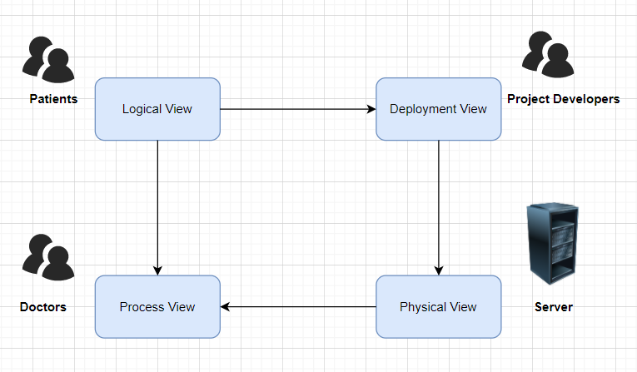

The architectural view of the system contains four components. First component is patients, which is the logical view of the systems, also called end users. Second component is doctors, which is also process view of the system doctors are authorized people to see the physical view which is application’s database. Third component of the system is deployment view, contains project developers. Another component is physical view contains server. The server is one server both includes web server and database server all the information collected from the application stored in this databases.

**4.2 Database Design/ER Diagram**

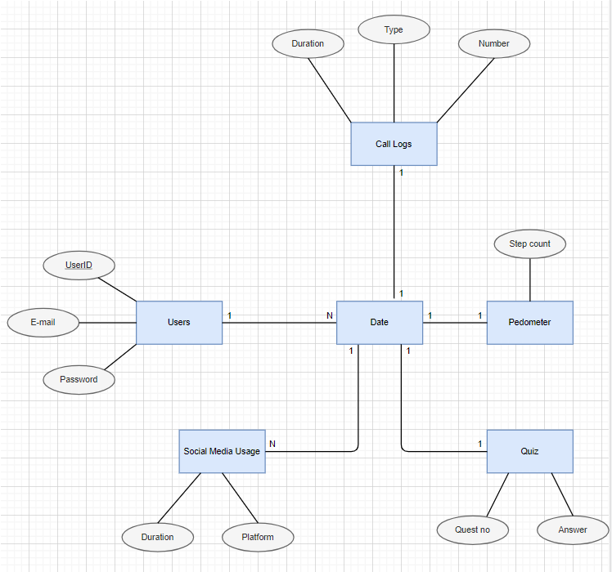

Figure 4.2 Database Design / ER Diagram

In the database of our project which represent in Figure 4.2 there are six table with names Users, Social Media Usage, Quiz, Pedometer, date and Call logs. The reason date table is in the middle of all other tables is because its values ​​are used by all other tables. Since Firebase database is used, the diagram differs from traditional ER diagrams.

There will be a 1,N relationship between users and date because, users information stored for every single day. Between date and Social media usage there is a 1,N relationship again the reason behind this situation is the platform numbers may differ. So, each date can have different social media usage from different platforms. Finally, all other relations are 1,1 because, all relations between date and pedometer, call logs and quiz.

**4.3 UML Class Diagram**

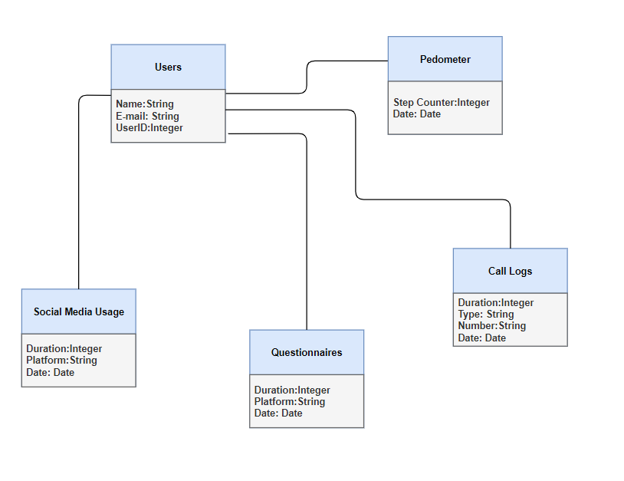

Figure 4.3.1 UML Class Diagram

In the UML diagram represent for the application shown in Figure 4.3.1, the types of attributes of the created tables can be seen. As can be seen, users name and E-mail attributes’ types are String and UserID’s is integer. For the social media usage duration’s type is integer and platform’s type is string. For the questionnaires duration’s type is integer and platform’s type is string. In the call logs table duration’s type integer, Type’s and Number’s are string. Finally in pedometer step counter is a integer. Also, there is a date attribute for all the tables. This attribute is common for all of them and the type of is the date is a Date type.

**4.4 UI Design**

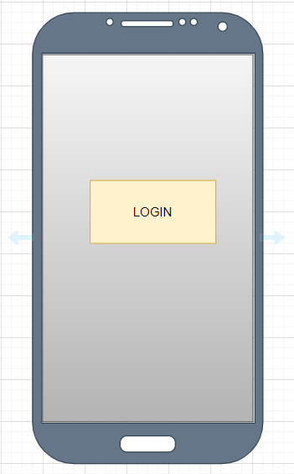

Figure 4.2.1 Login Screen

This screen shown above is the first one users encounter when the application is opened. Before using the application, users must log in to the application by clicking the login button in the middle and entering their personal information. After logging in, the main screen of the application will appear.

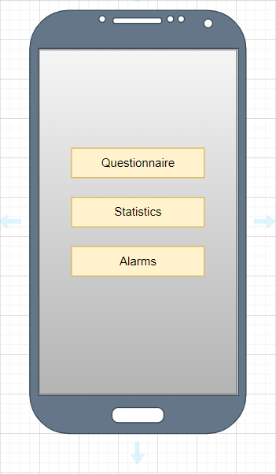

Figure 4.2.2 Main Screen

The main screen of the application can be seen in figure 4.2.2. This screen is the first one encountered after logging in. This screen guides the user to all other screens of the application. These screens are statistics, alarms and questionnaries. When the buttons on the screen are clicked, the related screens are opened.

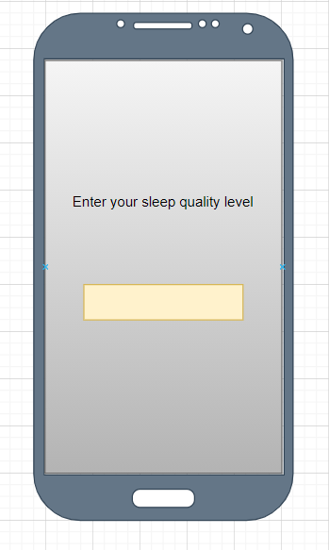

Figure 4.2.3 Questionnaires Screen

This screen is accessed by clicking the questionnaires button on the main screen. The questions that the user has to answer appear one by one. The user cannot proceed to the next question without answering any question. After all questions are answered, the main screen of the application comes to us. The user must answer these questionnaires every day. To ensure this situation, a notification can be sent to the user.

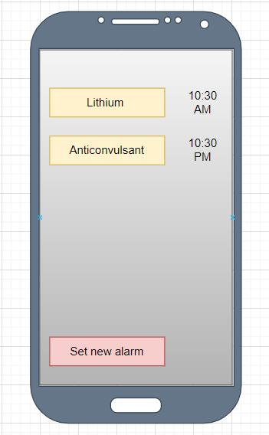

Figure 4.2.4 Alarms Screen

In this section, alarm information is displayed in front of the user. The user creates alarms by clicking the "set new alarm" button for each drug he uses. At the same time, you can see the alarms it has previously created in the middle of the screen and update their names and times by clicking on them. Generated alarms send sound notifications to the phone when the time comes.

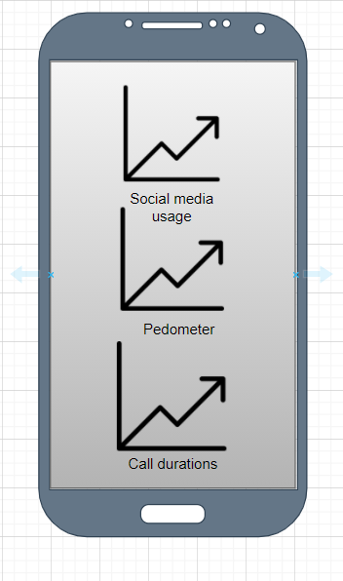

Figure 4.2.5 Statistics Screen

User can access the statistics screen seen above by clicking the statistics button on the main screen. On this screen, the user can see many data kept in the background by the application as graphics on the screen. This shared information is about daily step count, social media usage and call logs. On this screen, the information recorded in the last week is taken from the database and presented to the user. The graphs are updated every day as this new information comes in, and it is ensured that it continuously puts a week of data to the screen.

**4.5 Use Case Diagram**

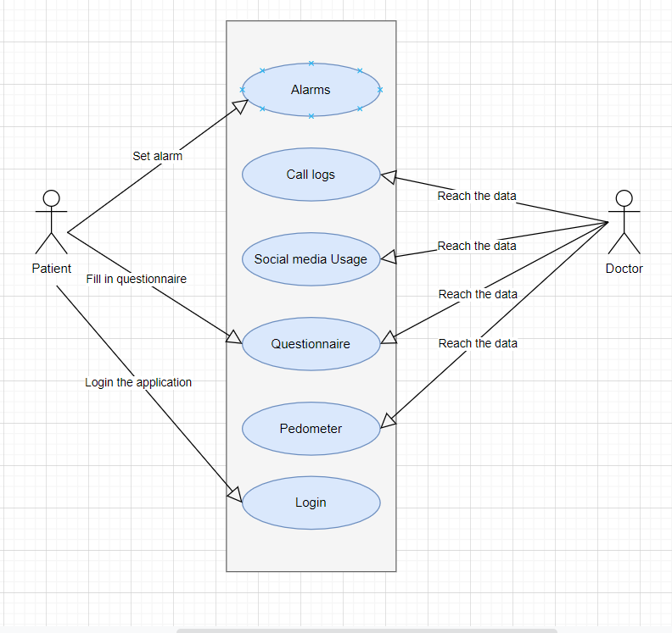

Use case of the system contains two actors. These are patient and doctor. At first, patient has to login the application with his information. Patient has to fill the questionnaire daily and set the repetitive alarms for the medicine which they are using. The other parts of an application call logs, social media usage and pedometer will be collected from the patient’s phone in the background. For these processes patient don’t have to do anything special. These parts are happens by itself. On the doctor side, all the data collected from patient’s phone stored in the database. Doctor can see the collected data all the time for see if there is a change in the patient's condition.

**4.6 Sequence Diagram**

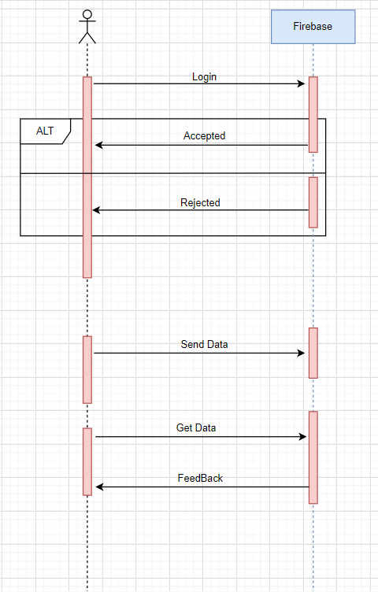

Figure 4.6 Sequence Diagram

The sequence diagram shown above tells us how the application works and the relationship between phone and database. As you can see, the user first sends a request to the database to login. It sends a respond to the database that it accepts or declines. The operations performed after this stage is carried out routinely. The application sends the information collected from the user to the database. Then, the application receives information from the database to present to the user and displays them to the user.

**4.7 Activity Diagram**

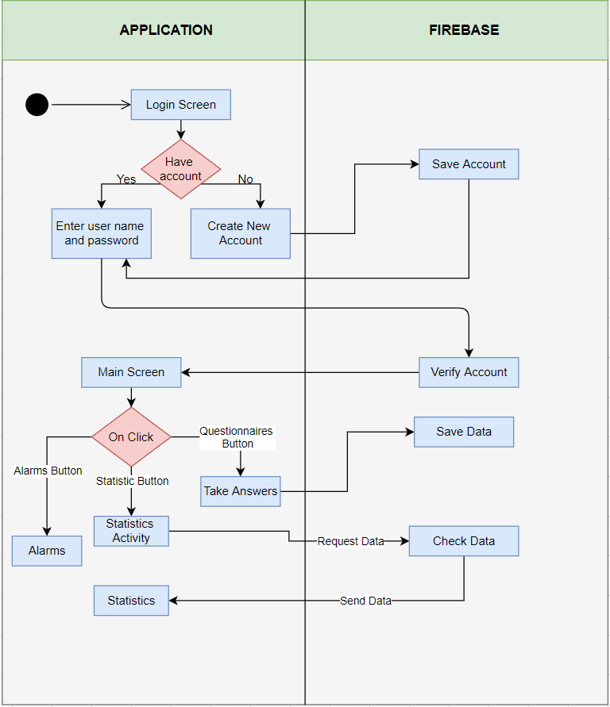

Figure 4.8 Activity Diagram

Activity diagram is a diagram in which the operations that can be done in practice are visualized. As can be seen from figure 4.8, the application starts with the login screen. Then the login process takes place. If users have an account they have created before, they log in with it. If users do not have an account created before, they should create a new account. After the login process is verified by firebase, users are directed to the main screen. The main screen contains three buttons. These are the alarms, statistics and questionnaire buttons. If users click on the alarm button, they perform their operations from the opened alarm page. By pressing the questionnaires button, the user solves the questionnaires and the results are saved in firebase. Finally, if the users click the statistics button, data is requested from firebase and the accessed data is presented to the users.

**CHAPTER FIVE**

**IMPLEMENTATION**

**5.1 Main Screen and Login**

First part of a project is main screen and login operations. In this part login operations and main screen created for the start of application.

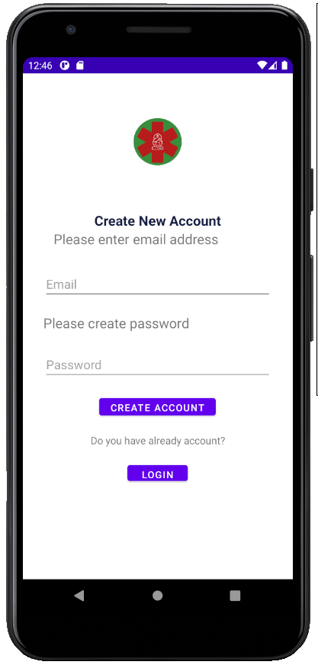

Figure 5.1.1Register Screen

In the register screen first of all user has to create an account for use the application if users already have an account, they can click login button to login the application. For the register part users have to enter e-mail and password information.

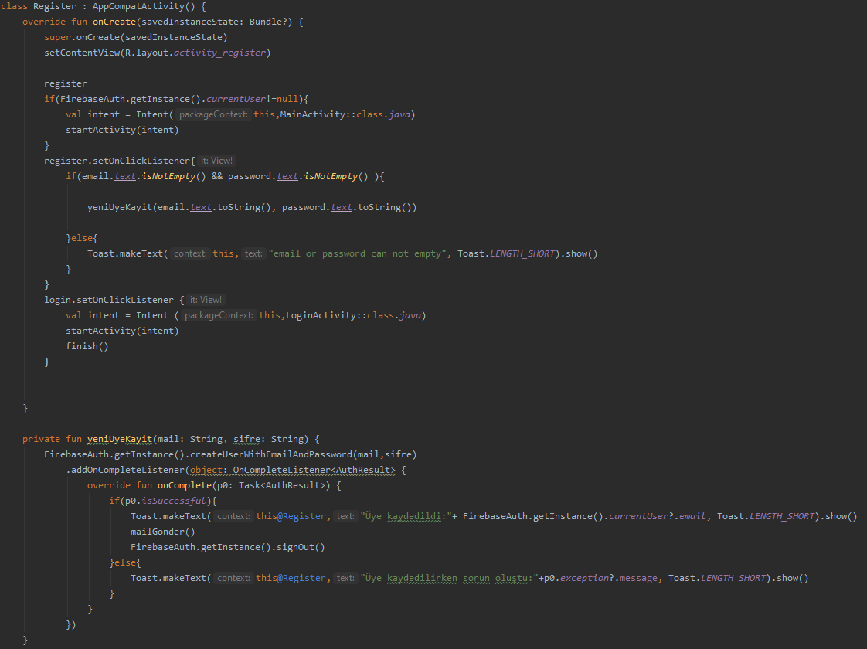

Figure 5.1.2 Code piece for Register

As you can see in the figure 5.1.2 for the registering email or password part cannot be empty. If users don’t fill this parts application send an error message. After user enter all the information, users’ information send to the firebase.

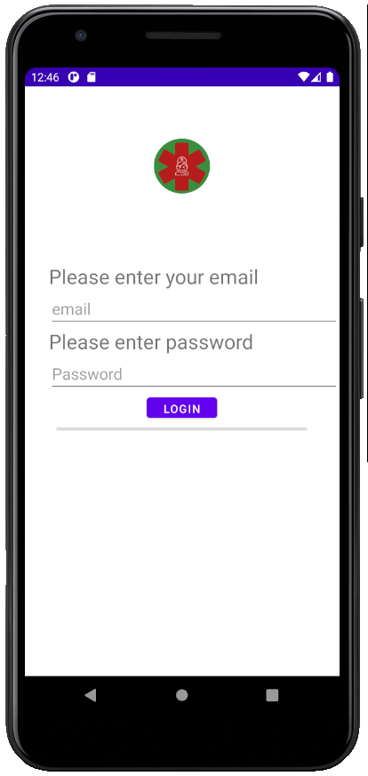

Figure 5.1.3 Login Screen

In the login part, users simply have to enter their information and start using the application.

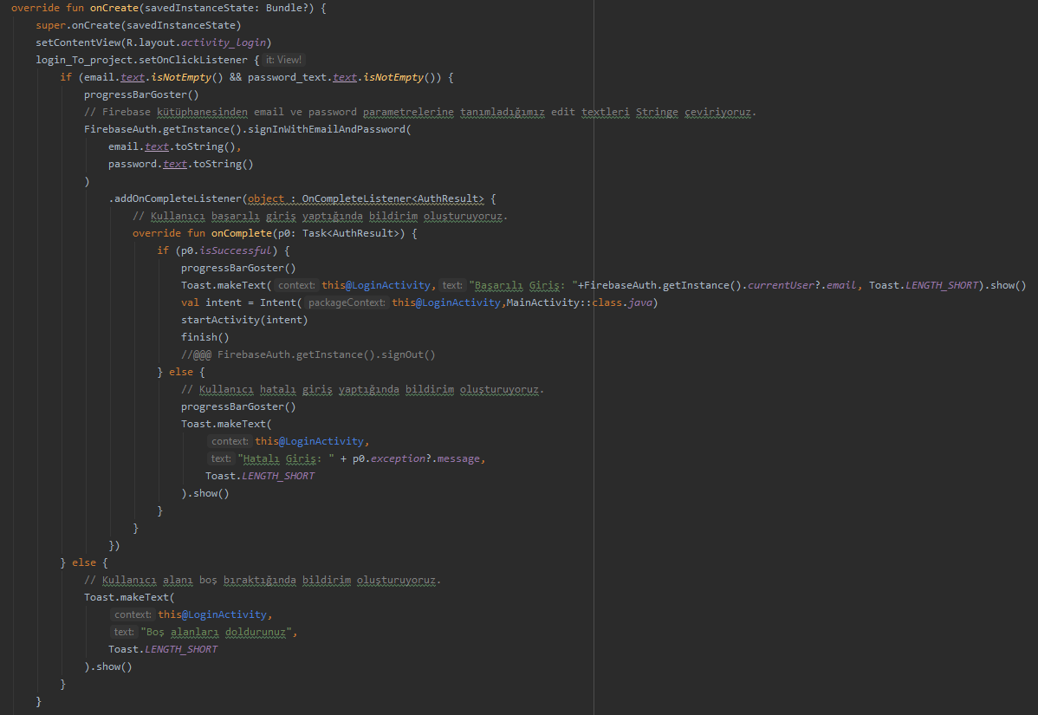

Figure 5.1.4 Code piece for Login Screen

As you can see in the Figure 5.1.4 application’s login operations done in this code piece. If there isn’t matched user in the system, application sends an error message to the users.

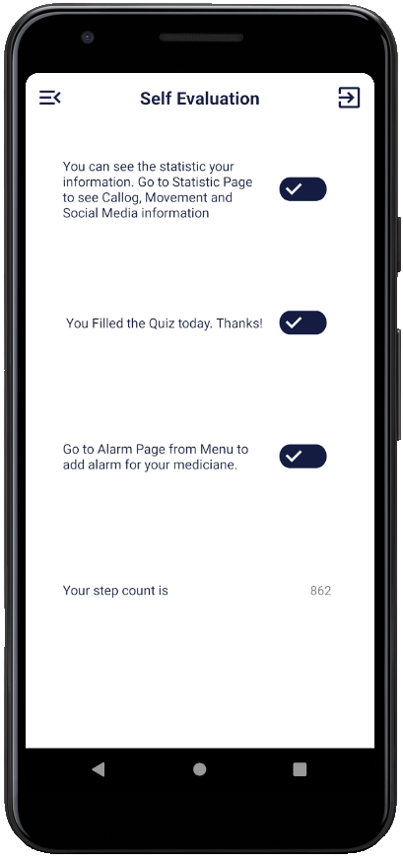

Figure 5.1.5 Main Screen

After login operations, users directed to the main screen of the application. In the main screen status of the application can be seen in the screen. In the screen contains some details on how the user will use the application and some information. By looking at this screen, it is understood whether today's test has been solved, the number of steps taken today and how to reach the statistics and alarm page.

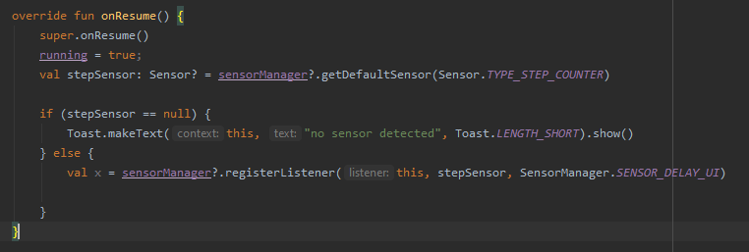

Figure 5.1.6 Step Counter

stepSensor on android phones was used to calculate the number of steps in the application. Thanks to this sensor, the number of steps taken by the user can be easily reached.

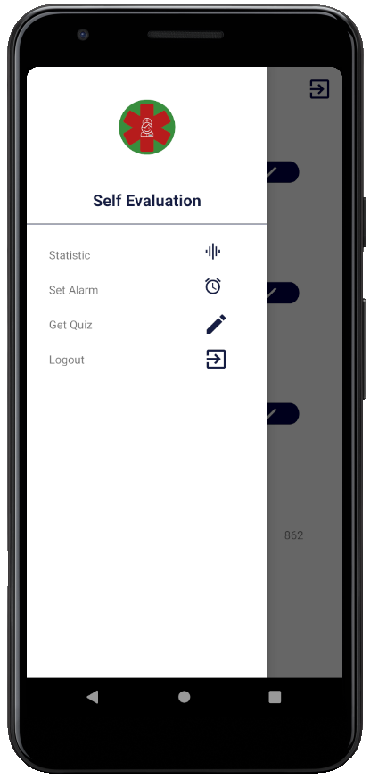

Figure 5.1.7 Navigation Bar Screen

Navigation bar opens when the button at the top left of the main screen is clicked. You can access statistics, alarms and quiz pages from this tab. At the same time, you can log out from the application by clicking the log out button at the bottom.

**5.2 Self-Assesment**

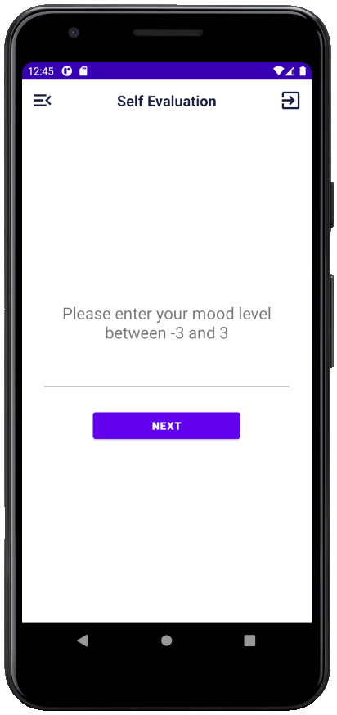

Figure 5.2.8 Questionnaires Screen

Click the quiz tab in the navigation bar menu to enter the questionnaires section. In this section, the questions come one after another. After answering each question, pressing the next button switches to a new question. After the test is over, the application will direct users to the home screen.

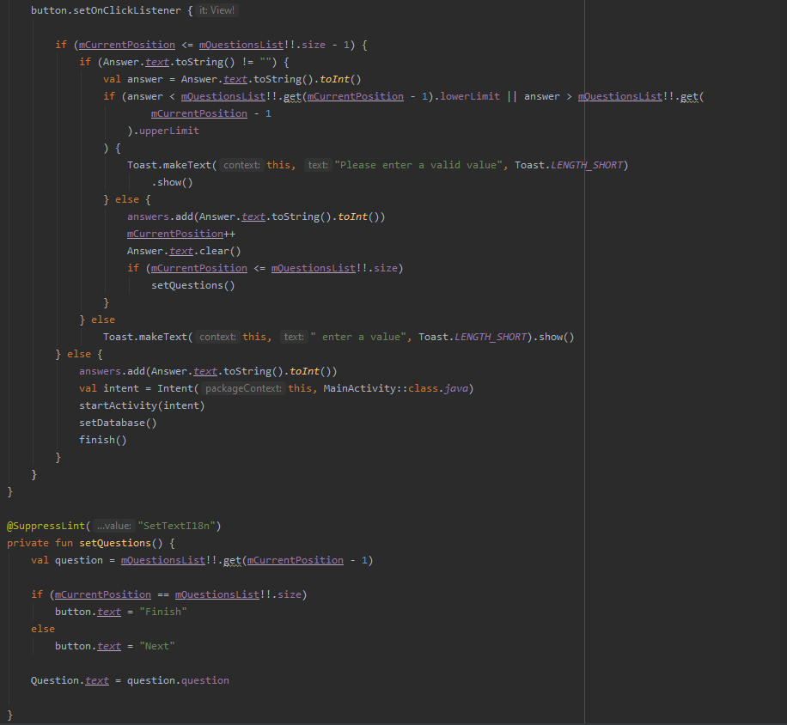

Figure 5.2.9 Code piece for Questionnaires Screen

The answers entered in this section are kept in a list called "Answers". After checking that the user has entered valid information, the "Answers" list is saved to firebase with the SetDatabase () function.

**5.3 Alarms**

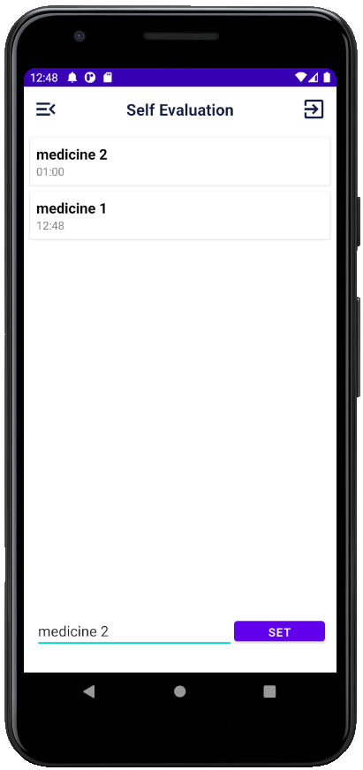

Figure 5.3.1 Alarm Screen

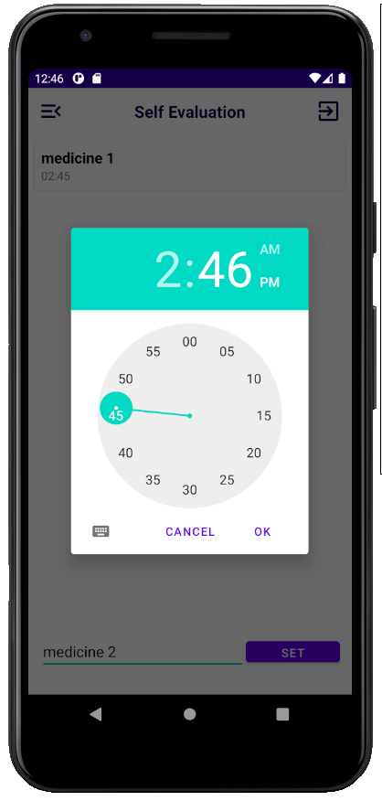

Figure 5.3.2 Setting an Alarm Screen

After entering the alarm tab, we will see figure 5.3.1. Here, users can view previously set alarms on the screen. If users press set screen on this screen, figure 5.3.2 appears. On this screen, users add a new medicine name and create a new alarm by entering the time they want at the opening time.

**5.4 Statistics**

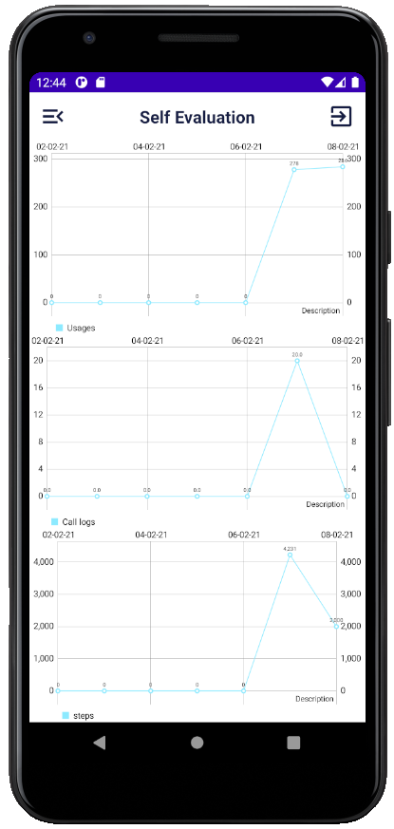

Figure 5.4.1 Setting an Alarm Screen

After clicking the statistics section in the application, the screen in figure 5.4.1 opens. On this screen, from top to bottom, the numbers of social media usage, call logs and steps can be seen graphically.

***5.4.1 Get Call data***

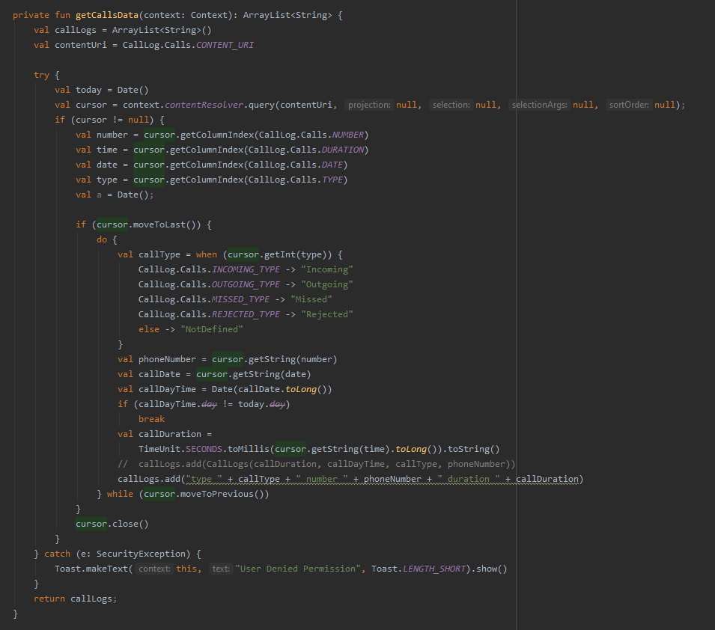

Figure 5.4.1.1 Codes for Get Call Data

CallLogs function on android phones is used to record the calls made by the user. This function records a lot of information such as the type, date and duration of the search. After the conversations are recorded with the callLogs function, they are sent to firebase.

***5.4.2 Get Social Media Usage data***

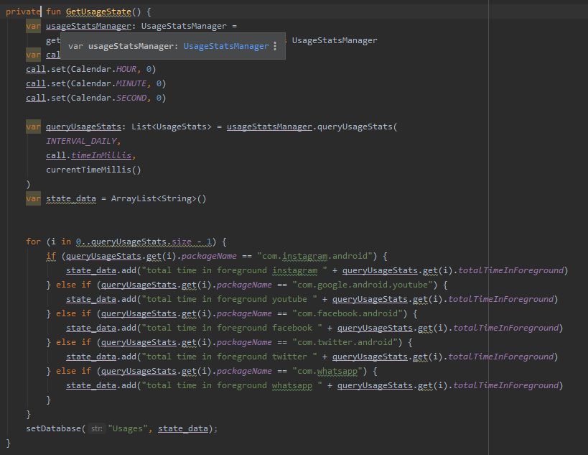

Figure 5.4.2.1 Codes for Get Social Media Usage Data

Social media usage data is also obtained by the queryUsageStats () function offered by android. With this function, it records the data of how much time the user spends in a day on whatsap, youtube, twitter and instagram applications. Then the collected data is uploaded to firebase.

***5.4.3 Get Data from Firebase***

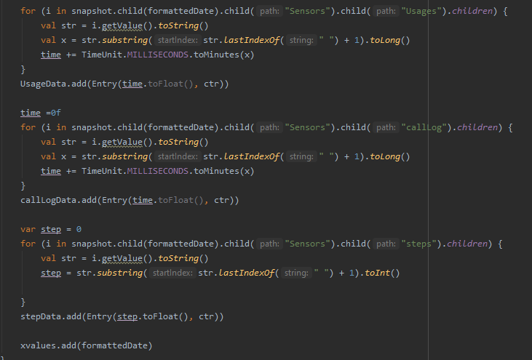

Figure 5.4.3.1 Code for Get Data From Firebase

After collecting all the data in firebase, we take all the data from firebase to use the collected data in statistics screen. The data received from firebase contains one week of information. After the information is taken from firebase and the formats are arranged, they are converted into graphics on the statistics screen.

**CHAPTER SIX**

**TEST AND RESULTS**

In project, the information was successfully transferred to firebase. this transferred information can be used by the patients' doctors. Thus, successful improvements can be achieved in patients' conditions.

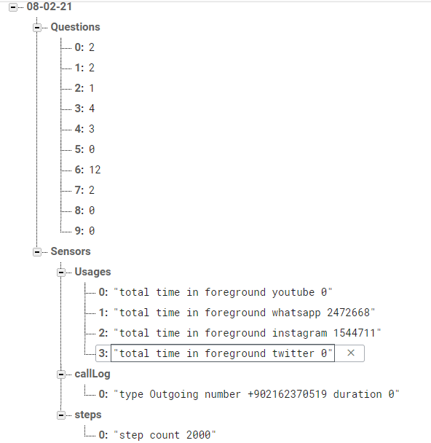

Figure 6.1 Collected data from Firebase

As can be seen in figure 6.1, information in firebase is kept separately for each patient. At the same time, since the dates are shown separately, an application that is understandable and easy to use for doctors have been made.

**CHAPTER SEVEN**

**CONCLUSION, CONTRIBUTIONS, FUTURE WORK**

As a result, a stable application that can be presented to the use of bipolar patients and doctors was carried out in the project. In the application made, information such as call logs, daily step information and social media usage were collected from the user's phone and uploaded to the database. In addition, the user is expected to questionnaire daily and the questionnaire is recorded in the database. In addition, it was ensured that the time of taking medication was arranged by setting an alarm for the patients' medication time.

Finally, this collected information was shown on the patient's own screen weekly, and the patient was aimed to make inferences. In addition, since the collected information can be accessed by the patient's doctor, the doctor-patient relationship has been strengthened and the doctor has been provided with more information about the patient. With all these studies, it is aimed to have a positive effect on the patients' conditions.

For future studies, the patients' conditions can be analyzed in the light of the information gathered, and which information is more valuable can be calculated. At the same time, the development of the application can be continued by adding new sensors and new information to the database. In this way, a lot of new and useful information about the effects and prevention of bipolar disease can be accessed.

**REFERENCES**

[1] Maria Faurholt-Jepsen, Maj Vinberg , Mads Frost , Ellen Margrethe Christensen, Jakob Bardram and Lars Vedel Kessing “Daily electronic monitoring of subjective and objective measures of illness activity in bipolar disorder using smartphones– the MONARCA II trial protocol: a randomized controlled single-blind parallel-group trial” , 2014

[2] MARIA FAURHOLT-JEPSEN, MAJ VINBERG, MADS FROST, SUNE DEBEL,

ELLEN MARGRETHE CHRISTENSEN, JAKOB E BARDRAM & LARS VEDEL KESSING , “ Behavioral activities collected through smartphones and the association with illness activity in bipolar disorder ”,2016

[3] Bardram, J. E., Frost, M., Szántó, K., Faurholt-Jepsen, M., Vinberg, M., & Kessing, L. V. (2013, April). Designing mobile health technology for bipolar disorder: a field trial of the monarca system. In *Proceedings of the SIGCHI conference on human factors in computing systems* (pp. 2627-2636).

[4] Narziev, N., Goh, H., Toshnazarov, K., Lee, S. A., Chung, K. M., & Noh, Y. (2020). STDD: short-term depression detection with passive sensing. *Sensors*, *20*(5), 1396.

[5] Khan, A., & Anwar, Y. (2018, September). Framework to Predict Bipolar Episodes. In *Proceedings of SAI Intelligent Systems Conference* (pp. 412-425). Springer, Cham.

[6] Dogan, E., Sander, C., Wagner, X., Hegerl, U., & Kohls, E. (2017). Smartphone-based monitoring of objective and subjective data in affective disorders: where are we and where are we going? Systematic review. *Journal of medical Internet research*, *19*(7), e262.

[7] Kajiwara, Y., Nakamura, M., Kimura, H., & Oyabu, T. (2017). A Mood Prediction System for Preventing Diseases Using Biological Information and Weather Information. *Electronics and Communications in Japan*, *100*(2), 12-24.